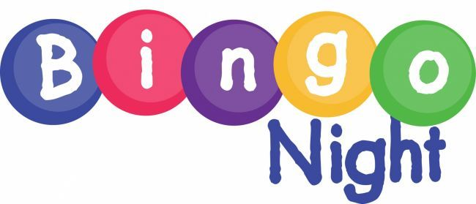

Friends and Family Bingo Night!
This Friday 9/30 @ Happy Valley School Cafeteria
From 6:30 to 8:00 PM
Fun times for everyone!

