Special Dress Days UPDATED
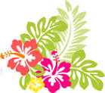 August 26 Class Color Day

September 30 Silly Socks/Shoes Day
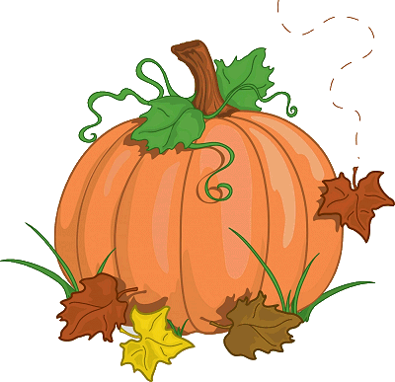 October 28 Fall Festival Day
November 18 Mismatch/Backwards/Inside-out Day 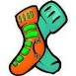 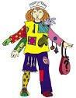
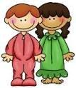 December 20 Pajama Day
January 27 Sports Team/Jersey Day 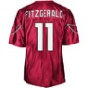
February 24 Decades Day 50s, 60s, 70s, 80s, 90s
March 31 Tie-Dye/Camo Day 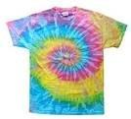 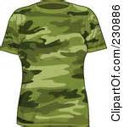
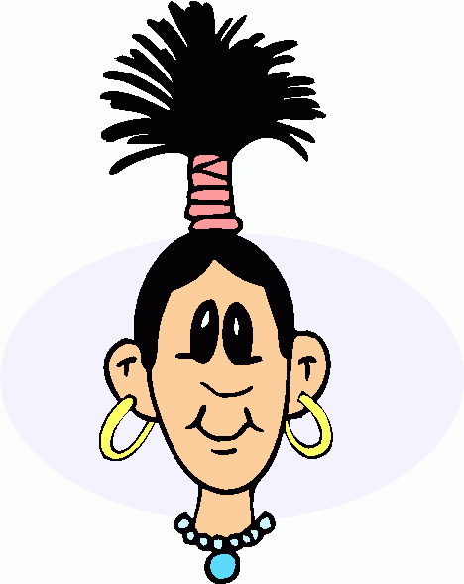 April 28 Crazy Hair Style Day (No colors, permanent or otherwise)
May 19 Hat Day

The HVS staff may wear denim jeans on Special Dress Days.

