Special Dress Days
August 25 Vacation/Beach/Tourist Day
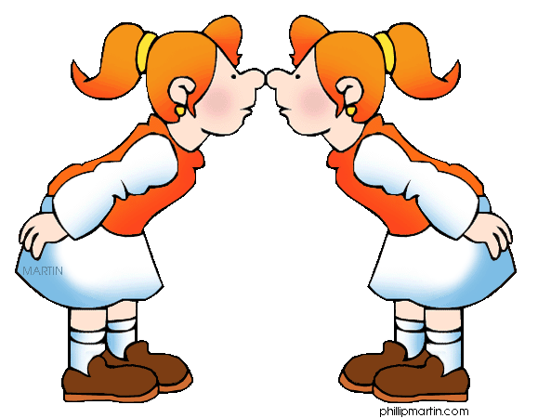

September 29 Look Alike Day (Dress like a friend)
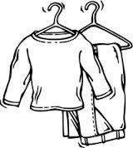
October 27 Whiteout/Blackout Day
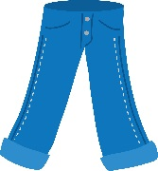
November 17 Jeans Day
December 20 Pajama Day
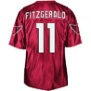
January 26 Sports Team/Jersey Day
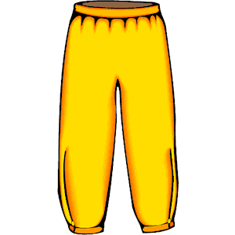
February 23 Sweatshirt/Sweatpants Day
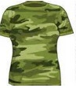
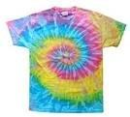
March 16 Tie-Dye/Camo Day
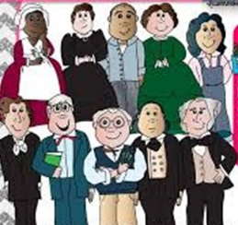
April 20 History Day (Favorite Historical Character)
May 18 Hat Day

