January 2016 Web Address: <http://happyvalleyschool.org/> Volume 2 Issue 4

**Eagle Gazette**

**Social Media**: *Happy Valley School*  @hvschool #hvseagles

**Happy Valley School*: Everyone, Every Day: High Standards, High Achievement***

***Mom and Son Game Night***

***Friday, January 29***

***6:30 p.m. – 8:00 p.m.***

Attention Gentlemen! You may ask your special lady (Mom) in your life on a date. Come in for a night of fun board games! You can bring your own favorite game from home or use one of ours.

We are also taking donations of board games that will go to umom.org to families in need. Come to a fun event and help a good cause at the same time.

We are asking for $2 per couple to cover expenses.

Don’t delay! Go to the Parent Team tab on the school website to sign up.

***School Blog***

Don’t know what’s going on at HVS? Subscribe to the School Blog. You can find a link to the blog **near the top of our website**. If social media is your thing, follow us on Twitter or Facebook.



***Important Calendar Events***

**January**

**15** Father Daughter Luau Dance

**18** Martin Luther King Jr. Day

(No School)

**22** February Lunch Orders Due

**29** Free Dress (Jersey Day)

Mom and Son Game Night

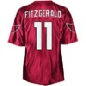

***Father and Daughter Luau Dance***

***Friday, January 15***

***6:30 p.m. – 8:00 p.m.***

It’s Hula time! Everybody loves luau and the magic of the Hawaiian Islands. So put on your grass skirt, a Hawaiian shirt, and some sandals, because the tropical party will be at HVS.

Our tropical paradise will have dancing with fun music, limbo, and hula hooping.

We are asking for $2 per couple to cover expenses.

Don’t delay! Go to the Parent Team tab on the school website to sign up.

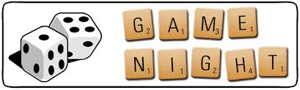

***A Note from the Principal***

Dear Parents,

Happy New Year!

Our parent team leaders have been hard at work with organizing various events this school year. They need your help with this month’s events. To volunteer for the Father and Daughter Luau Dance or the Mom and Son Game Night go to the Parent Team tab on the HVS website.

Thank you for your continued support.

Mr. Born

